**LEOATARD ORDERS MUST BE SUBMITTED BY Sept 25th.
They take 10-12 weeks to receive so they should be in by Christmas.
Leotards are optional for all dance, cheer, gymnastics students EXCEPT Team gymnasts
Levels 3+ must have a long sleeve leotard.
Levels 1&2 can pick either but MUST have one of the new design.
Our old design cannot be worn for competitions this year. All other students can get a leotard if they want.
**We recommend that you measure your gymnast and use the comfort fit. These leotards run VERY small.

2021-22 Leotard Order Form
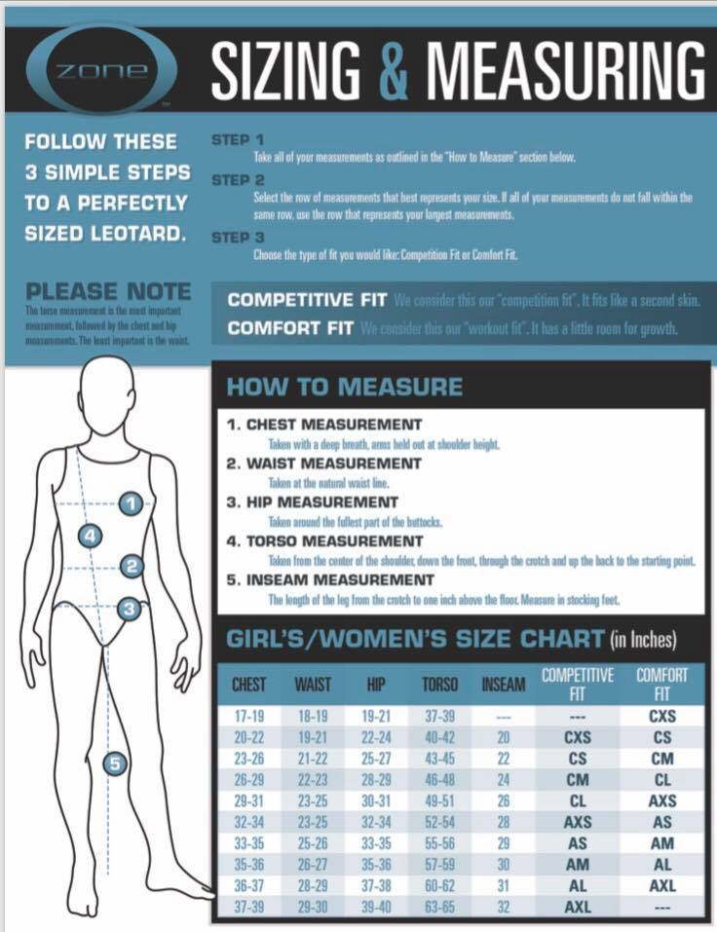
Size Options: CXS, CS, CM, CL, AXS, AS, AM, AL, AXL
Price: Short Sleeve is $70, 3/4 Sleeve is $140.
Short sleeve has sequins and long sleeve has rhinestones.

Order Here:
Long Sleeve or Short | SIZE | Price
1.
2.
3.

NAME:
AMOUNT DUE: Payment: CASH or CHECK Check #:
Would you like this order kept a secret from your child? YES NO

